**Student Written Assessment (Assignment)**

|  |  |  |  |
| --- | --- | --- | --- |
| **Business Unit/Work Group** | IT Studies | | |
| **Qualification Code** | ICT50715 | **Qualification Title** | Diploma of Software Development |
| **Unit Code/s** | ICTPRG527 | **Unit Title/s** | Apply intermediate object-oriented language skills |
| **Assessment Task Title** | Book Assignment | | |
| **Student Name** | Submit your solution via your LEARN account | **Student SIS ID** | Submit your solution via your LEARN account |
| **Assessor Name** | You have been added to a LEARN group which defines your assessor. This is normally your Course Registration Number (CRN) lecturer. | **Date** | 2018 Semester 1 |

|  |  |
| --- | --- |
| **Student Guide for Written Assessment (Assignment)** | |
| **Overview of Assessment** | This assessment will require you to complete a partially implemented version 2 apps re;ated to a basic shopping cart for books.  In this assessment you will cover the following topics:   * Use of binary files to write & read objects * Use of a database to store data * Database table operations – create * Database data operations – insert, update & delete   The assessment is broken up and assessed in 2 parts and you will submit each part gradually as you develop your skills through the course. |
| **Task/s to be assessed** | This is a practical task and will require you to code, test and document in the Java language in the Android environment. The following pages will define the specific tasks you need to complete. |
| **Time allowed** | You have the whole course duration to complete this assignment, however each part has its own submission date.  The submission dates for each part are provided in the LEARN course and summarized in the Assessment Submissions topic in LEARN. |
| **Location** | You can complete this assessment during your practical sessions and at home. |
| **Decision making rules** | To receive a satisfactory outcome for this assessment you must complete all parts correctly. |
| **Assessment conditions** | You must follow the provided ITWorks Java & Android coding standards in completing this assessment. |
| **Resources required** | To complete this assignment, you will need to use Android Studio (latest version) and have been provided with Android Studio projects containing portions of the code. Android Studio and Windows based machines are provided in your practical classes. You can use a Mac if you prefer but these are not provided in the classrooms. |
| **Results/Re-assessment** | You will be provided feedback for each part of the assessment and be given the opportunity to resubmit with any required corrections only once. |

# BOOK CATALOG Assignment

You have been employed by the ITWorks organisation as a junior Android programmer. Your job is to complete two simple Book Selection Apps.

The overall purpose of the apps is to allow the presentation of a list of books and for the user to add or remove books from their shopping cart.

Others have already worked on these apps and some code has been developed, Android Studio projects of previous work are provided. The code has //TODO comments where the developer did not get a chance to finish the code. Two projects are provided.

Your role will be to complete both versions so that the lead developer at ITWorks can investigate which version would function most efficiently and be most versatile.

* Binary_File_Book_Catalog – This has a simple version of the Book Catalogue app. It is meant to use a binary file to save the users choice of Books to add the cart between runs of the app. The file handling code is incomplete.
* Database_Book_Catalog – This is a more complex version of the Book Catalogue app with more features than the binary file version. It uses a database but some of the database code is incomplete.

# Part 1 – Binary Files

You have been asked to complete the Binary_File_Book_Catalog project by coding the missing methods in the DAO class – *BookShoppingCartFileDAO.*

You are provided with an Android Studio project called Book_App_Binary_Files_Incomplete_Version of the previous programmers work.

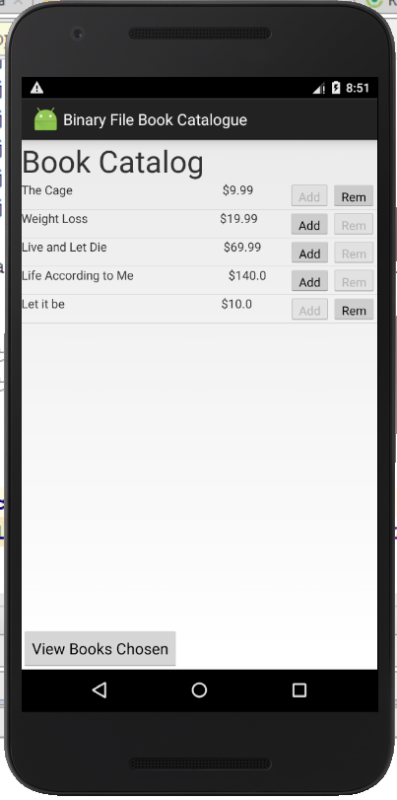 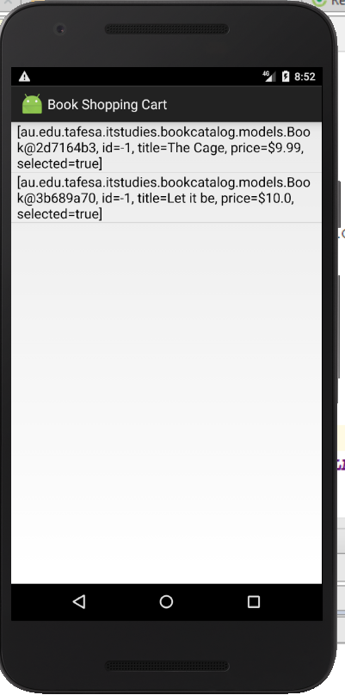

The second activity appears when the “View Books Chosen button is pressed

* **Program Requirements**Ensure the following requirements are met:
  + The app must be developed for Android SDK Version 22.
  + Store all data as guided in the partially completed BookShoppingCartFileDAO class. This class has //TODO comments in the two methods that are incomplete loadFromBinaryFile and saveToBinaryFile
  + When the app is closed the file will be updated.
  + When the app starts again the file will be used to initialise the model.
* **Coding**

Code the solution that meets the above requirements and ensuring that

* **Best Practices**:  
  Follow the provided ITWorks organisational guidelines for developing Android code
* **Testing**  
  To demonstrate that you have adequately reviewed the program requirements and produced the required functionality you must document some testing by submitting a word document containing screen shots of the running of your complete solution and a screen shot showing where on the device the binary file gets created – using the DeviceFileExplorer. Call the word document Part1_Book_Assignment_Test_Results_YourName.docx. The screen shots need to validate that the app state is properly re-instated when the app is restarted.
* **Submission summary:**
* Zip file of your Android Studio project with all classes completed. You may delete any components of the dist (distribution) folders except the javadoc folder to reduce the size of the zip file.
* Word document called Part1_Book_Assignment_Test_Results_YourName.docx containing screen shots of the running of your tests.

# Part 2 – Using a Database

You have been asked to complete the Database_Book_Catalog project by coding the missing methods in the DAO class – *BookShoppingCartDBDAO.*

You are provided with an Android Studio project called Book_App_Database_Incomplete_Version of the previous programmer’s work.

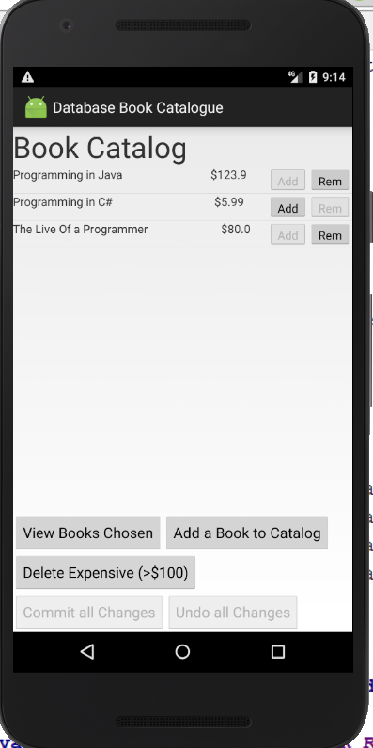 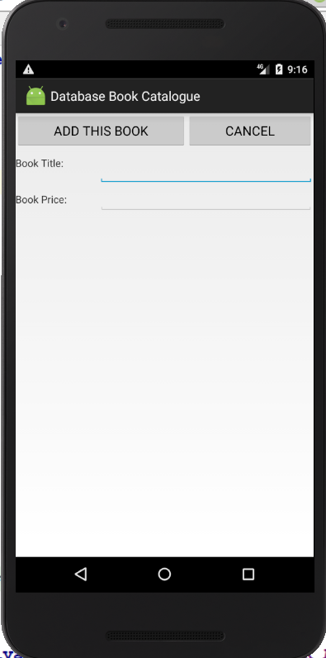

* View Books Chosen: works the same as the Binary File version of the app
* Add a Book to Catalog: opens second Acivity to allow new Book to be added.
* Delete Expensive Books will remove all books over $100 from the catalog.
* The “Committ all Changes” and “Undo all Changes” buttons are only selectedable when changes have been made. They will save or undo all changes since the last Committ/Save
* **Program Requirements**Ensure the following requirements are met:
  + The app must be developed for Android SDK Version 22.
  + Use the database design provided in the next section.
  + Store all data to the database as guided in the partially completed BookShoppingCartDBDAO class. This class has //TODO comments in the methods that are incomplete loadFromDB and saveToDB , deleteExpensive, some methods in the database helper class and some in the BookCatalogActivity class.
  + Ensure the functionality of all of the interface buttons as explained in the above diagram and guided by the in-code comments.
  + When the app is closed the DB will be updated.
  + When the app starts again the DB will be used to initialise the model.
* **Coding**

Code the solution that meets the above requirements

* **Best Practices**:  
  Follow the provided ITWorks organisational guidelines for developing Android code
* **Testing**  
  To demonstrate that you have adequately reviewed the program requirements and produced the required functionality you must document some testing by submitting a word document containing screen shots of the running of your complete solution and a screen shot showing where on the device the Database file gets created – using the DeviceFileExplorer. Call the word document Part2_Book_Assignment_Test_Results_YourName.docx. As a minimum the screen shots need to validate that
  + The app state is properly re-instated when the app is restarted.
  + The Add new book is functioning correctly.
  + The Delete expensive books is functioning correctly.
  + The Commit and Undo buttons are functioning correctly
* **Submission summary:**
* Zip file of your Android Studio project with all classes completed. You may delete any components of the dist (distribution) folders except the javadoc folder to reduce the size of the zip file.
* Word document called Part2_Book_Assignment_Test_Results_YourName.docx containing screen shots of the running of your tests.

**Database design details.**

There is only one table used for the Books Catalogue app:

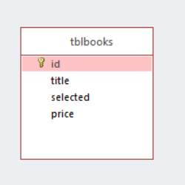

CREATE TABLE IF NOT EXISTS tblbooks

(id INTEGER PRIMARY KEY autoincrement,

title TEXT,

selected INT,

price NUMBER)